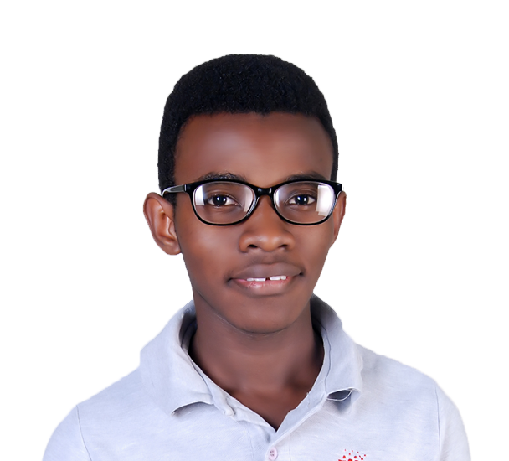

**Kasasira Charles Derrick**

**+256750118523 |** [charleskasasira01@gmail.com](mailto:charleskasasira01@gmail.com) **| charleskasasira.github.io**

I am a Technology enthusiast actively learning new skills hoping to get something worth sharing.

**TECHNICAL SKILLS**

Adobe Photoshop : Which i use for graphics graphics design, and i use the software to design posters, Business Cards and many more.

Adobe Illustrator: which i use for graphics design, build sharp logos and vector designs

HTML5: Which i use to structure my websites.

CSS3: Which i use to style websites.

**EXPERIENCE**

**Graphics Designer**

***July - Sept 2020***: I had the opportunity to work with Goph Technologies(now WHD Technologies, whd.biz) as a graphics designer mainly designing logos and social media posts.

**Freelance Graphics Designer**

I have design posters, logos, and flyers for various businesses and organisations. I have put some of my work on instagram (Byte Of Hope)

**FAMILIAR WITH**

Wordpress, Python, Flutter, Adobe After effects, Premiere pro and Blender

**EDUCATION**

**2019 – to date:** Pursuing a bachelor's degree in **Computer Science**  at Makerere University

**April 2021 – to date:** Was among the 6 candidates selected to participate in a Solver Course scholarships at Ablestate Creatives Limited.

**2018:** Uganda Advanced Certificate of Education (**UACE**) attained from London College of St. Lawrence.

**2016:** Uganda Certificate of Education (**UCE**) attained from St. Stephen’s college Bbajja.

**TREASURES**

**Team work**

I’m passionate about working in teams and in 2018, I led the chemistry class of London College as a class representative bridging the gap between the administration, teachers and students.

**Willingness to learn**

I am actively learning and looking for various ways to learn and develop news skills. This ability has pushed me to apply for various opportunities including the Solver scholarship for which I was selected to participate at Ablestate Creatives Limited.

**CONTACTS**

Tel: +256 750118523

Email: [charleskasasira01@gmail.com](mailto:charleskasasira01@gmail.com)

Namuwongo 8th Street,

Kampala, Uganda